***AG Cox “2.3”***

***Raiders are Changing the Game!***





***23-24 Student-Parent Handbook***

***A. G. Cox Middle School***

2657 Church Street

Winterville, North Carolina 28590

Telephone: (252) 756 - 3105

Website: http://agcoxmiddleschool.com

Dear A. G. Cox Families,

**Welcome Back to School!** The faculty and staff join me in saying we are happy to have you as a part of our learning community. It is our sincere desire that this will be a **successful year** for you and your child.

A.G. Cox knows this school year may seem different from previous years, however we will continue to have **High Expectations** for each student, team, and grade level. For a productive year, hard work, commitment and dedication on the part of the administration, faculty, support personnel, student, and parent will be necessary. Changes can be exciting and challenging, please know that we are here to work with you and your parents/guardians to make the change process a meaningful experience. We highly encourage you to work collaboratively with our staff so that we can make decisions based on what is **Best for Students**. Within this handbook, you will learn about our school and district policies, regulations, procedures and services. Please read this information carefully, discuss it with your child, and keep it readily available throughout the year.

I look forward to working with you and your child towards having a great school. Thanks in advance for all of your support.

Sincerely,

N. McDuffie

Principal

**Raiders ROCK!**



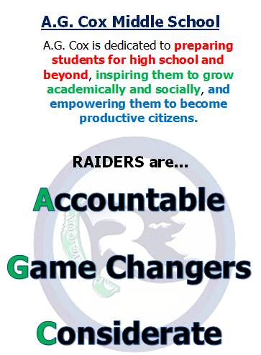

**Table of Contents**

A. G. Cox Middle School Staff …...............................................................................6

Middle School Concept ..............................................................................................8

Core Subjects ..............................................................................................................8

Performance Criterion for Accelerated Math and Math One………………..............9

Use of Calculators..................................................................................................... 10

Extended Core Subjects............................................................................................. 10

Grading Policy …….................................................................................................. 14

Homework …............................................................................................................. 14

Mid-Marking Period Progress Reports ..................................................................... 14

Promotion-Retention ................................................................................................. 14

Report Card Schedule…………………………………………………………...…..14

Media Center ............................................................................................................. 15

Extra-Curricular Activities ........................................................................................ 15

Interscholastic Sports ................................................................................................ 16

**General Information**

Arrival at School ........................................................................................................17

Late Arrival to School ...............................................................................................17

Dismissal Procedure …..............................................................................................18

Early Dismissal...........................................................................................................18

Car Riders and Walkers………. ............................................................................... 18

Visitor Policy ........................................................................................................... 18

Closed Campus ......................................................................................................... 19

Phones ........................................................................................................................19

Cell Phone Policy……………………………………………………………………19

Use of School Facilities.............................................................................................19

Fee Schedule……………………………………………………………..….....…...20

Student Dress Policy and Appearance……...............................................................21

Emergency/Safety Drills ........................................................................................... 22

Use of Medication..................................................................................................... 22

Riding Bicycles ......................................................................................................... 22

Attending Assemblies ............................................................................................... 22

Student Awards/Recognition .................................................................................... 22

Parent Teacher Association ……………………………………………………….. 23

**School Counseling Services**

Counseling Services ..................................................................................................23

Parent-Teacher Conferences ..................................................................................... 24

Parent Expectations, Involvement, and Responsibilities........................................... 24

School-Based Committee .......................................................................................... 24

Teacher Assistance Team......................................................................................... 24

Withdrawal Procedures ............................................................................................. 24

Student Services........................................................................................................ 24

Harassment ………................................................................................................... 25

Peer Mediation .......................................................................................................... 25

**Student Code of Conduct**

Expectations & Consequences ..................................................................................25

Gang and Gang Related Activities…………………………….………...….…........26

School Bus Discipline Policy ....................................................................................26

Out of School Suspension..........................................................................................27

A.G. Cox Classroom Discipline Continuum……………………………..……........27

A.G. Cox Classroom Rules…………………………………………………………30

A.G. Cox Expectation Matrix………………………………..…..………………....31

Bell Schedule…………………………………………………………...…………..32

**A.G. Cox Vision**

A.G. Cox is dedicated to **preparing students for high school and beyond**, **inspiring them to grow academically and socially**, **and empowering them to become productive citizens.**



**RAIDERS are…**



.

**A.G. Cox Classroom Rules**

**Allow the teacher to teach by...**

1. Following directions the first time they are given, and thereafter.
2. Waiting for permission to speak.
3. Staying in your seat unless you have permission to do otherwise.
4. Keeping hands, feet, and objects to yourself.
5. Speaking positively to others.



**A. G. Cox Middle School Staff**

***Administrative Staff***

Norman McDuffie, Principal Latisha Wooten, Secretary

Linda Brantley, Asst. Principal Kimberly Prayer, Powerschool Data Manager

Chaquita Avent-Holloman, Asst. Principal Cayla Owens, Bookkeeper/Payroll

***Instructional Support Faculty Members***

Teressa Raser, Media Coordinator Tina Heath, Media Assistant

Rachel Kelly, Instructional Coach Deana Landis, Counselor

Demetrise Cobb, Counselor

***Sixth Grade Teachers***

Jill Mullis Room 514

Susan Drake Room 509

Michael Keyes Room 510

Stacey Gardner Room 608

John Tankersley Room 607

Shelly Cahoon Room 609

Candace Hines Room 512

Xavier Guions Room 513

Chris Setser Room 508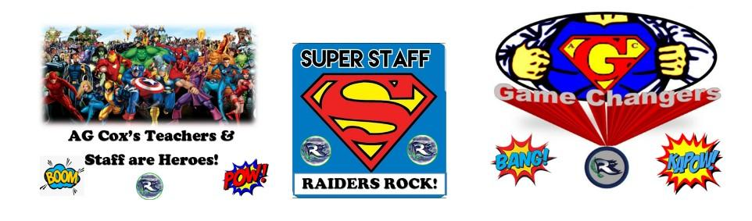

***Seventh Grade Teachers***

Chad Moore Room 306

Diamond Roberson Room 308

Jeff Cahoon Room 316

Andy June Room 317

Jonathan Messer Room 407

Carie Harris Room 307

Victoria White Room 318

Laura Cintron/ Ralph Smith Room 408

Allison Streeter Room 410

***Eighth Grade Teachers***

Diana Pepino Room 715

Chip Cayton Room 702

Elizabeth White Room 712

Emily Leary Room 708

Mica Pierson Room 711

Aurora Watson Room 709

Leeann Halliday Room 704

Melissa Miller Room 713

James Blount Room 714

Lindsey Gunderson Room 705

Michael Smith Room 703

***Exceptional Children Teachers***

Sarah Williams, ID-Mild & Moderate Room 125

Ginnett Bland, AIG Room 305

Sonya Smith, AIG Room 610

Sharon Jarman, GEN SPED Room 605

Michelle Roberts, GEN SPED Room 710

Elouise Payton, GEN SPED Room 315

Angela Cunningham, AU Room 126

Jenna Dinkins, DHH & Equity and Inclusion Room 122

***Encore Teachers***

Kimberley Gaylord, Computer Technology/Keyboarding Room 413

Travis Savage, Band Room 205A

Elizabeth Crawford, STEM Room 604

Haywood Dillahunt, Health & PE Gym

Jaqueline Hobbs, Art Room 506

Marti Wilson, CTE Room 412

Treandrea Wilkins, Health & PE Gym

Meredith Hall, Strings/General Music Room 413 (Mobile Unit)

Penny Gardner, General Music/Chorus Room 414 (Mobile Unit)

Richard Spence, Health & PE Gym

Susan Nguyen, Dance Room 411

Amy Staton, AVID Room 408

***Behavior Support Staff***

Behavior Support Teacher Media Center

Velez Dunn, ISS Coordinator Room 206A

***Teacher Assistants Lunchroom Staff Custodial Staff***

Christian Perez, IDMI Jackie Mills, Manager Alonza Blackledge-Head

Donna Lloyd, IDMI Afrika Moye Harrison Thompson-Lead

Peggy Allen Robert Battle

Chericka Ward Jahdon (JJ) Holloway

***Interpreters***

Tyrone Armwood, DHH

**Middle School Concept**

Our middle school program has several distinguishing features and components that will enable students to make a smooth transition from elementary school to high school. The following information will provide students and parents a better understanding of the middle school concept.

**Interdisciplinary Team Organization**

To create smaller and more personal communities of learning, we are organized in interdisciplinary teams. The interdisciplinary team organization is a group of two or more teachers from different subject areas who have a common group of students, a similar schedule with common planning, and share the same part of the building. During team planning time, the teachers address both the academic and affective needs of students within their program.

**BLOCK CLASSES/BELL SCHEDULE**

Students will take classes in the four core subject areas: English/Language Arts, Math, Science, and Social Studies. Students will also have two encore classes daily. All encore classes, except AIG, band, orchestra, some dance classes, and chorus, are taught on a semester basis. AIG, band, orchestra, some dance classes, and chorus are year-long classes. **Students and their families must register for band, chorus, and orchestra. Students must meet local and state eligibility guidelines to participate in AIG. All other encore classes will be randomly assigned.** Students may be assigned a second semester of Physical Education based on course availability.

AIG students who are enrolled in band, chorus, orchestra, and year-long dance may opt out of Physical Education in order to take the two year long classes. Parents of AIG students who wish for their child to take band, chorus, or orchestra will be required to sign a Pitt County Schools’ physical education opt out waiver. This waiver only applies to AIG students in band, chorus, or orchestra or yearlong dance.

**CORE SUBJECTS  
*Science***

The state of North Carolina developed the science curriculum with the ultimate goal of assisting students in seeing how science directly relates to their lives and the larger human population. There is a shift of emphasis from content specific objective science to science processes, with a great emphasis on the thinking skills used in problem solving.

***Social Studies***

The middle grade social studies program focuses on five major concepts--history, geography, economics, political science, and sociology/psychology. The program of study at each grade level will enable students to investigate and respond to basic questions about our state, our nation, various countries of the world, and ancient civilizations being studied.

***English Language Arts***

The communication skills curriculum is spiraling in nature and contains the same broad goals for kindergarten through grade twelve. The intent of the program is to equip students with the skills needed to participate as informed and effective citizens in a democratic society, to function effectively in the world of work, and to realize personal fulfillment. Students are taught to communicate through reading, writing, speaking, listening, and viewing. A broad range of experiences with a wide variety of good literature is a part of the focus. Several outstanding novels have been selected for use with the middle level program. Writing is taught using the entire writing process including grammar, spelling, and capitalization.

***Mathematics***

The middle grades mathematics program offers students of all ability levels the opportunity to develop a better understanding of numbers, improve their ability to reason and be exposed to some exciting new areas of mathematics. The topics emphasized at these grade levels are operations on rational numbers, beginning algebra, informal geometry, measurement, graphs, scale drawings, elementary probability & statistics, and problem solving. The use of calculators and computers to enhance and enrich the program is also encouraged.

***7th and 8th Grade Students***

* 7th Grade Mathematics
* 8th Grade Mathematics
* High School
  + Math 1, Math 2, Math 3 or High Level Math Course with Math 3 as a prerequisite

\***Note:** Students that follow this math sequence they will meet the

mathematics qualifications for entering one of the sixteen campuses of the University of

North Carolina Higher Education System.

***7th Grade Accelerated Mathematics*** is a transition course between arithmetic and algebra. Students who successfully complete the Accelerated Mathematics may enroll in Common Core Math I or 8th Grade Mathematics depending on their final grade average. The student who takes Accelerated Mathematics and Common Core Math I at the middle school level could take the following math courses in high school: (Accelerated mathematics is prerequisite for Common Core Math I in grade 8)

| * 9th grade Common Core Math II | * 10th grade Common Core Math III |
| --- | --- |
| * 11th grade Higher level math course with Math III as prerequisite: Advanced Functions/Modeling, Pre-Calculus | * 12th grade Advanced Functions/Modeling, AP Calculus, Discrete Math, or AP Statistics |

\***Note**: If students choose to follow the Accelerated Mathematics sequence, they will meet the mathematics qualifications for entering one of the sixteen campuses of the University of North Carolina Higher Education System.

***Math I***is offered for eighth grade students who generally intend to complete four years of high school mathematics at the honors level (geometry, algebra II, pre-calculus, calculus). Mastery of algebraic skills is essential for the successful completion of higher level mathematics. Students who elect to enroll in this course would generally perform at a high proficiency level of the mathematics multiple-choice section of the End-of-Grade test, maintained a high “A” average, earn a Level 4 or 5 on the previous year’s math EOG, and within the Top 30% Math Percentile on his/her grade level. All students who complete the course are required to take the North Carolina READY End-of-Course Math I Test.

Students electing to enroll in Math I in the eighth grade intend to complete four years of high school mathematics at the honors level:

| * 9th grade Common Core Math II | * 10th grade Common Core Math III |
| --- | --- |
| * 11th grade Pre-calculus or higher level math course with Common Core Math III as prerequisite | * 12th grade Higher level math course with Math III as prerequisite: Advanced Functions/Modeling, AP Calculus, AP Statistics or Discrete Math |

Students who score proficient as identified by state and local guidelines will earn high school credit. This credit can be applied to high school graduation. However, it will not impact a high school student’s grade point average. High school grade point average begins when a student enters 9th grade.

**\*Note:** If students chose to follow the Math I sequence, they will meet the mathematics qualifications for entering one of the sixteen campuses of the University of North Carolina Higher Education System.

***PERFORMANCE CRITERION FOR ACCELERATED MATH OR COMMON CORE MATH I***

Any student who is not performing satisfactorily in Accelerated Math or Common Core Math I may elect to drop the course **before the 60th day of school** . **All students enrolled in Common Core Math I as of day 60 MUST remain in the course for the remainder of the school year.** Common Core Math I students will be required to take the North Carolina READY End-of-Course Math I Test. This exam counts as 25% of the yearly average. Any student failing Accelerated Mathematics may repeat their grade. Any student failing Common Core Math I may repeat their grade.

**USE OF CALCULATORS**

Students are encouraged to use DESMOS calculators. Handheld calculators may also be used for instruction at the discretion of the teacher.

**EXTENDED CORE SUBJECTS (Encore Classes)**

***Year Long Classes***

***Sixth Grade Beginning Band Class***

Beginning band focuses on learning to read music and how to play a band instrument. Through the use of method books, sheet music, recordings, and performing opportunities, the beginning band student will develop skills in music reading and performing.

***Seventh Grade Band Class***

Students should have at least one year in band and be able to play on grade level with the rest of the class. Seventh grade band class should be a continuation from the sixth grade band year. Students will continue to increase their technical proficiency, aural discrimination and gain more knowledge of music reading and performing.

***Eighth Grade Band Class***

Students should have completed at least two years of band and be able to play on grade level with the rest of the class. Eighth grade band class should be a continuation of growth and development from the seventh grade.

***Sixth Grade Chorus***

Beginning Chorus focuses on learning to read music and how to develop a healthy, expressive, and effective singing voice. Through the use of a variety of repertoire, regular sight reading activities, and performing opportunities the Sixth Grade Chorus student will develop skills in music reading, vocal expression, and performing.

***Seventh Grade Chorus***

Students should have at least one year in Chorus and be able to sing on grade level with the rest of the class. Seventh grade Chorus class should be a continuation from the sixth grade chorus year. Students will continue to increase their technical proficiency, aural discrimination and gain more knowledge of music reading and performing.

***Eighth Grade Chorus***

Students should have completed at least two years of chorus and be able to sing on grade level with the rest of the class. Eighth grade Chorus class should be a continuation of growth and development from the seventh grade.

***Sixth Grade Dance I Class***

Beginning dance will focus on fundamentals of dance including the importance of warm-ups, basic dance techniques in a variety of genres, as well as the history of dance. This class will have a performance opportunity in the spring.

***Seventh Grade Dance II Class***

This class is a continuation and growth in the development of dance techniques and choreographic principles with performance opportunities. Students enrolled should have successfully completed a dance course in sixth grade.

***Eighth Grade Dance III***

This class is a continuation and growth in the development of dance techniques and choreographic principles with performance opportunities. Students enrolled in this class should have successfully completed a dance course in seventh grade.

***Sixth Grade String Orchestra***

Beginning orchestra focuses on learning to read music and how to plan an instrument. Students develop an ideal sound, a sense of good intonation, correct position, posture, and bowing. The basic fundamentals of music reading and performing are stressed.

***Seventh Grade String Orchestra***

Students should have played in an orchestra at least one year and be able to play on grade level. Seventh grade strings should be a continuation of sixth grade orchestra. Students continue to develop musical understanding and playing techniques.

***Eighth Grade String Orchestra***  
Students should have played in orchestra at least two years and be able to play on grade level. Eighth grade orchestra should be a continuation of the seventh grade year. Students continue to develop music reading ability and performing skills. There should be evidence of a clear concept of ideal tone and intonation, while demonstrating an advanced level of facility with the bow and left hand technique.

***Semester Classes***

***Sixth Grade General Music Class***

Students will continue to develop their understanding of musical concepts initiated in K-5 general music. They will participate in activities that build their vocal, listening, music reading, and instrumental skills, as well as those which encourage their own creative efforts.

***Seventh Grade General Music Class***

Students will further their understanding of music concepts. They will participate in activities designed to refine their vocal, music reading, listening, and instrumental skills. They will continue to develop their own creativity by working with various musical compositions.

***Eighth Grade General Music Class***

Students will broaden their understanding of musical concepts. They will apply their acquired knowledge in creative activities while continuing to build their vocal, instrumental, listening, music reading, and analysis skills.

***Sixth Grade Visual Art***

Students in art classes will study artists and art history, as well as produce their own creative artwork in drawing, painting, printmaking, sculpture and ceramics. They will learn to discuss art and to think creatively in problem solving.

***Seventh Grade Visual Art***

Building on experience from sixth grade art classes, students will continue to study artists and art history. In art production, they will use many of the same media in a more advanced way. Special emphasis will be placed on creative problem solving and art criticism, which involves understanding and discussing art.

***Sixth Grade Dance I***

Students will focus on fundamentals of dance including the importance of warm-ups, basic dance techniques in a variety of genres, the impact of one dance globally, and history of dance.

***Seventh Grade Dance II***

Students will focus on dance fundamentals with emphasis on choreography and integration of the seventh grade core curriculum.

***Eighth Grade Dance III***

Students will focus on dance fundamentals with emphasis on choreography and integration of the eighth grade core curriculum.

***Health and Physical Education***

Health and physical education is offered to all students in grades 6-8 for 90 days. Physical education is alternated with health education units. The main focus of the physical education curriculum at this level is the areas of fitness, gymnastics, dance, and games and sports. Students participate in high level concepts and skills each school year in these areas. The specific objectives to be accomplished at each level are discerned in the North Carolina Standard Course of Study.

***Strength and Conditioning***

In health class, students will be made aware of the important health risks for their age group and be able to appraise their own health status, health behaviors, and potential for health risks. Focus will be on understanding how to protect themselves from health risks arising from substance abuse and intimate sexual behaviors.

***STEM***

The STEM lab was created to expose students to a curriculum that incorporates Science, Technology, Engineering and Math through hands-on activities. The students work through Modules using a computer program and then complete a physical project or lab that reinforces the main objectives of the Module lesson.

### 6th Grade

**Innovating Solutions** - In *Innovating Solutions*, students learn about the processes used to develop new ideas, inventions, and innovations including problem-solving models, the engineering design loop, and the Universal Systems Model of technology.

**Building Bridges** - In *Building Bridges*, students work as civil engineers for the Plan-it Span-it bridge construction company while exploring types of bridges and the roles civil engineers play in the design and construction of bridges and other projects. Students work through the stages of the engineering design process as they design, plan, construct, and test a model balsa bridge using given specifications. Students also learn how to use equipment designed specifically for building the model as well as techniques to improve the design.

### 7th Grade

**Theme Park Physics** - In *Theme Park Physics*, students explore the physics of amusement park rides, especially the role energy plays in causing these rides to be fun yet safe. They design roller coasters and other rides to determine the relationships between potential and kinetic energy.

**Contraptions** - In *Contraptions*, students explore how simple machines are used to accomplish work. Students conduct an experiment to see how energy and work are conserved when using simple machines. Working together, students explore the six classical simple machines, the use of simple machines throughout history, modern applications of these ancient devices, and how the mechanical advantage of these machines affects the effort required to perform a task. The Expedition culminates with the Siege Machine Challenge in which students engineer a siege machine that is made up of two or more simple machines.

### 8th Grade

**Tower Power** - In *Tower Power*, students work as civil engineers for the Tower Up construction company, exploring the purposes of towers and the roles civil engineers play in the design and construction of towers and other projects. They work through the stages of the engineering design process while designing, planning, constructing, and testing a model balsa wood tower using given specifications. Students also learn how to use equipment designed specifically for building their model as well as techniques to improve the design.

**Rolling Robots** - In *Rolling Robots*, students work as robotics drive engineers for the Fleet Robots corporation. Students learn how and where robots are utilized, explore gear arrangements to change the speed of a robot, and assemble a robot with metal beams and plastic connector pieces.

***Middle School Career-Technical Education***

**1. Keyboarding -** Keyboarding and Business Computer Technology are designed to develop keying and formatting skills, appropriate techniques, and basic technology applications. These two courses combined make up the high school keyboarding curriculum.

**2. Keyboarding and Business Computer Technology courses will be offered only as semester courses as written in the Standard Course of Study.**

**3. All students will be required to take the CTE statewide post-assessment (VoCATS) to measure achievement and to establish a clear connection between instruction and accountability.** Teachers know from the course blueprint what should be taught in their classes and even the approximate time that should be used to cover each topic. They know at the beginning of the course what students will be evaluated on and even the exact number of questions that will be asked on each objective. They can use the classroom assessment banks to test students throughout the course, monitor student progress, and determine which students need remedial activities. The statewide post-assessments should reinforce what teachers already know about their students' mastery of course content.

**GRADING POLICY**

1. Teachers are charged with the responsibility of grading students and recognizing their

individual differences. Grading should be based on the progress the individual student has

made towards accomplishing the goals and objectives set for him/her by the teacher in

cooperation with the student and parent.

2. All classes will be graded in accordance with the following numeric scale:

100-90 = A

89-80 = B

79-70 = C

69-60 = D

59 and below = F

**HOMEWORK**

Homework is an integral part of the educational process and will be reflected in all students’ final grades.

When absences occur, parents may call the school and request their child’s assignments. Assignments can be picked up from the main office. If a student prefers to wait until he/she returns to school to make up assignments, he/she has up to 5 days to do so, depending on the number of days absent.

**MID-MARKING PERIOD PROGRESS REPORTS**All students will receive progress reports in the core courses. In encore classes, only students in danger of failing or making drastic drops will be given progress reports. Please review this report with your child(ren), sign it, and return it to your child(ren)’s homeroom teacher.

1. The week of September 25, 2023
2. The week of December 11, 2023
3. The week of February 26, 2024 (Promotion/Retention letter if applicable)
4. The week of May 6, 2024 (Promotion/Retention letter if applicable)

**PROMOTION-RETENTION STANDARDS**

Refer to page 10 of the 22-23 Pitt County Schools’ Parent/Student Handbook.

**REPORT CARDS**

***Marking Period End of Marking Period Report Cards Go Home***

1 October 31, 2023 November 8, 2023

2 January 22, 2024 January 31, 2024

3 April 4, 2024 April 10, 2024

4 June 7, 2024 Mailed Home

**A. G. COX MEDIA CENTER**

The A. G. Cox Media Center supports efforts to encourage reading for enjoyment, curriculum needs, and sponsors our school’s Battle of the Books Team.

Students will go to the library with their ELA teachers to check out books. A student is allowed to have two (2) books checked out at any one time for a two-week period. Books may be renewed once. If a book becomes overdue, he/she may not check out any other books until his/her name is cleared by either returning the book(s) or paying the prorated price listed on the overdue list. If the book is found later within the same school year, the money may be refunded. A student’s report card will be held until a book is cleared.

If a book is returned damaged, the student will be charged a fee. Failure to pay these damages will result in the student’s name being added to the overdue list.

**EXTRA-CURRICULAR & ADDITIONAL ACTIVITIES**

Young adolescents need a variety of experiences well beyond those contained in the core or extended core curriculum. At A. G. Cox, students are offered a wide range of extra-curricular activities. Descriptions are included below of some of the various extra-curricular offerings.

***Student Council Association***

The Student Council Association is composed of school-elected officers and homeroom-elected representatives in grades 6 - 8. These representatives assist in promoting school projects and in reporting any information that students may need to know to their homerooms. The purpose of the Student Council is to carry out school projects and to teach leadership skills and parliamentary procedures.

***Math Teams***

Sixth, seventh, and eighth grade students may opt to participate in Math Counts or Algebra Team. Students may be asked to take an exam to be considered for participation on either or both of the teams.

***Band/Orchestra***

A. G. Cox students in 6th, 7th, and 8th grades may choose band, or orchestra as an encore class. Beginning band is offered to 6th graders and advanced band to 7th and 8th graders. Arrangements can be made through the band instructor to rent instruments or students may prefer to purchase their own instruments. Students in band and orchestra are involved in several performances each year and are graded on participation in those performances. Participation in band and orchestra is a privilege and offers students an opportunity to develop skills as performers, as well as a greater appreciation for music.

***The National Junior Beta Club***

The purpose of the organization shall be to encourage effort and regard merit among students and to promote those qualities that make for good citizenship in the school community. Those students in grades 6 - 8 who, in the opinion of the administration of the school, are of worthy character, good mentality, creditable achievement, and commendable attitude shall be eligible for membership.

***Science Teams***

Sixth, seventh, and eighth grade students may opt to participate in Environthon and/or Science Fair. Students may be asked to take an exam to be considered for participation on either or both of the teams. Students may also participate in our school sponsored Science Fair.

***Battle of the Books***

Students, who are interested in this competition, read books selected by the N. C. Battle of the Books committee and try out for the school team by answering questions about the books they read. The team then competes against other teams from Pitt County Schools in a quiz bowl format.

***Field Trips***

1. Field trips are an enjoyable educational extension of the regular classroom. They supplement

and enrich the curriculum and offer students the opportunity for first hand learning

experiences.

2. All field trips must be approved by the principal. Overnight field trips and out-of-state field

trips must be approved by the Superintendent of Pitt County Schools.

3. All field trips are carefully planned and well organized by staff sponsors. Careful attention is

given to providing more than adequate supervision and every precaution is made to ensure

student safety.

4. While participating in or attending as representatives of the school, to any school-related

activity held on school grounds or at some other location, students are subject to the same

rules and regulations concerning conduct which apply during the regular school day.

5. All school rules apply when students are on field trips.

6. Parent meetings will be held prior to any out of state field trip. The purpose of the meetings

will be to familiarize parents with the itinerary, rules, and regulations and provide helpful

hints.

***INTERSCHOLASTIC SPORTS***

A. G. Cox Middle School takes great pride in our athletic program. Through quality leadership, community support, and parental involvement, we are able to offer student athletes quality equipment and facilities. As a result, we have been quite successful in our interscholastic athletic program.

***Sports Offered at A. G. Cox Middle School***

**Fall Winter Spring**

Cheerleading Boys’ Basketball Baseball

Cross Country Girls’ Basketball Co-ed Soccer

Football Cheerleading Softball

Volleyball Wrestling Track & Field

The responsibility of educating and guiding student athletes in the regulations governing interscholastic athletic eligibility shall rest with the administration of each school. Student athletes and parents of student athletes share the responsibility to see that the interscholastic athletic regulations are followed.

***Pitt County Eligibility Requirements***

Refer to page 18 of the 2022-2023 Pitt County Schools’ Parent/Student Handbook

***Conduct at Athletic Events***

While participating in any school-related activity held on the school grounds or at some other location, or attending as representatives of the school, all students are subject to the same rules and regulations concerning conduct which apply during the regular school day. Rule violations may result in suspension, removal from game, and loss of privilege to attend future games or events.



**General Information**

**ARRIVAL AT SCHOOL**

The school day for students begins promptly at 8:10 a.m.

**EARLY BIRD**

We recognize that it is convenient for some parents to drop your child off at school before 8:10 a.m. As a service to parents who wish to do this, A. G. Cox has established an **EARLY BIRD** program in our gym from **7:00 a.m.-8:10 a.m.** Students must pay **$2.00 per day** to enter the gym and be a part of this program. Early Bird students who choose to eat breakfast will report to their homeroom at 8:10am.

Students may enter the building at 8:10am. Students who choose to eat breakfast will walk directly to breakfast (cafeteria), then homeroom. Students not eating breakfast will report to their homeroom at 8:10am.

Bell to Report to Homeroom...…………………………………………..8:10 am (All Students)

Tardy Bell to Homeroom………………………………………………...8:25 am (All Students)

Start of 1st CORE……………………………………………………….8:30 am (All Students)

Staggered Dismissal from School….…….………………………………3:30 pm & 3:32 pm

**LATE ARRIVAL TO SCHOOL or CLASS/EARLY DISMISSAL**1. Students are expected to be in the class when the school day begins at 8:30 am.

2. Students arriving late to school are to **report to the office** to be counted present for the day

and obtain a pass to class. Proper documentation (a note from a health care provider, a note from court, or other issue as outlined in PCS Policies and Procedures) must be provided to

receive an excused tardy. All tardies without proper documentation will be counted as unexcused.

3. Students are allowed four (4) minutes between classes to arrive and be in their assigned class.

4. The school day ends at 3:30 pm. Parents are discouraged from checking students out

early. **Parents will not be allowed to check out students after 3:00pm.** Please note that repeated early

dismissals/late arrival may cause missed instructional time, which may impact performance. This can be

referenced on page 21 of the Pitt County Schools’ Parent/Student Handbook.

5. If a person other than the parent or legal guardian is to pick up the student, their names must

be listed on the student’s A.G. Cox pick-up list.

6. The person picking up the student must come in the office and sign the student out of school.

**Students will not be called out of class to sit in the office to wait for the parent or**

**guardian to get to the school**. Students will be called once the person picking up the student

checks in at the main office.

7. The person picking up the student, including the parent or guardian, will be asked for **picture**

**identification.**

8. If a person other than the parent picks up the student on a regular basis, written permission

may be given and kept on file in the office.

9. **Students leaving prior to 12:00 noon will be counted absent for the entire day.** All

students must sign out before leaving school premises. Parents must report to the office to

pick up their child--not the classroom.

10.After school arrangements for your student should be clearly understood **before** your child comes to school.

**Telephone messages to your child at school or to the office staff to change afterschool**

**transportation will not be accepted.** The only exception will be in cases of serious

emergency. **NOTES ARE REQUIRED TO TEACHERS AND OFFICE EXPLAINING**

**ANY CHANGE IN HOW YOUR CHILD IS TO GO HOME.**

**DISMISSAL PROCEDURE**.

Dismissal from School….…….……3:30 pm (Group A)…….3:32 pm (Group B)

Once students are outside the building, students should walk to their bus on Blount Street or to Church Street for car rider pick-up. Students in mobile units should not walk through the building, but must walk outside. Teachers will stand at their doors and follow students out of the building to monitor behavior. **Bus riders must get to their assigned bus in a timely manner or risk being left behind. Parents are then responsible for picking up their student. After school dismisses, all students must leave campus unless participating in athletics or they have received written permission from school administrator, or teacher.**

**Pitt County Schools’ K-8 Unexcused Tardy/Early Dismissal Procedures**

| Days  Tardy/Early Dismissal | Consequences |
| --- | --- |
| 3 to 6 | Contact from Administration  (may be Connect5, Letter, or Phone Call) |
| 8 to 10 | May be assigned an additional consequence for each subsequent tardy/early dismissal  (Possible suspension of up to 2 days) |
| 15+ | School based meeting with parents or Social Worker Visit may be assigned an additional consequence for each subsequent tardy or early dismissal. |

**ATTENDANCE POLICY**

Regular attendance is necessary to the success of all students. Upon returning to school after an absence, the student should bring a written excuse to his/her homeroom teacher. This excuse should include the name, date(s) of the absence, the reason, and the signature of the parent. The responsibility of make-up work must be initiated by the student within five days after returning to school. According to the Pitt County Board of Education policy, a student who is absent a total of twenty-one days per school year for reasons defined as lawful **or** unlawful could automatically fail the work for that class for the schoolyear.

**Car Riders and Walkers – PICK-UP & DROP-OFF – Sylvania Street**

1. Parents bringing their children to school or picking them up in the afternoon are to use the curbside in the

front of school. Parents are asked **not to park** on the school curbside, as to block traffic. Students should not be dropped off in the middle of the street.

2. Sylvania Street is open only to teachers and Facility Services traffic. Parents are asked **not** to park in spaces on Sylvania Street, as these are reserved for teachers.

**Teacher/Staff Appointments**

A.G. Cox works to maintain the instructional time and the safety of our students, faculty, and staff. For this reason, visitors are asked to schedule an appointment with teachers and staff.

1. Upon arrival, press the small, round, silver button located on the right of the main entrance

doors.

2. The front office staff will answer.

3. Visitors need to say their name and verify their appointment

4. The office will unlock the door.

5. **Visitors must sign in the automated check-in system and have an ID to obtain a visitor’s pass**

**from the office.**

7. Students are not allowed to bring younger brothers, sisters, friends or relatives from other

schools.

**CLOSED CAMPUS**

1. We operate a closed campus policy.

2. Students must stay on the school grounds from the time they arrive, until dismissal or until they are picked up by the bus, a parent, or guardian.

**PHONES**

1. Students must ask a teacher’s permission to use the telephone within the classroom.2. Students desiring to use the office phone must have a permission slip or pass from a teacher.

3. We ask that parents avoid calling the school to speak to their child or leave messages, except

in emergency situations.

4. Please make note of the PCS Parent/Student Handbook regarding the use of cell phones by

students.

**CELL PHONES**

**Cell phone checks are allowed during transitions and lunch. Cell phone use in the classroom is only allowed with the teacher’s permission.** If they are seen or heard by any adult without permission, they will be taken and logged into the front office. The cell phone will be released to a student's parent/guardian. **As per Pitt County Schools’ Policy, students may use cell** **phones for instructional purposes with teacher permission. Students recording inappropriate student behaviors will be subject to school consequences.**

**USE OF SCHOOL FACILITIES**

School facilities are provided for the students’ use and convenience. It is hoped that each student will display pride in his school and make an effort to maintain the facilities. Following are several recommendations that should be observed in the use of these facilities.

• Classrooms - The majority of your school day will be spent in the classroom. Do your part to keep your own classroom neat, attractive, and clean. Refrain from marking on the walls or desks.

• Cafeteria – Students will go the cafeteria as a team and will report back to the classroom to eat. Microwaves will not be available this school year. To encourage good nutrition, a well-balanced lunch is offered at a reasonable price. An ala carte line is also available. Students should be encouraged to choose wisely. The cafeteria management and your fellow students will appreciate your cooperation in the following:

Whether using the cafeteria for assemblies, classes, pre-school or post-school activities, students should not play on the stage. Place chairs back in their proper place and refrain from littering the floor.

• Media Center - Our library is a resource center for learning, to be used for reading, research, and browsing. Books checked out should be taken care of so that others may benefit from their use. Damaged or overdue books will be paid for by the students.

• Campus - Take pride in our campus and keep papers and litter off the grounds and encourage others to do so.

• Gymnasium - Coaches have requested that physical education classes remove any shoes except white soled tennis shoes while using the gymnasium. Respect school physical education equipment by using and storing properly.

• Instructional Equipment - Such items as data projectors, document cameras, Classroom Performance Systems, Chromebooks, Netbooks, laptops, I-Pads, Smart Boards, and I-Pod Touches should be handled with the care and permission of the classroom teacher, as damages result in expensive and often lengthy repairs. **Copy machines should be used by teachers and personnel only.**

• Office - Any personal belongings found on school grounds should be turned into the office. Any student missing personal belongings should check in the office. **However, the school cannot be responsible for money, cell phones, books, clothing, etc. left unattended.**

# FEE SCHEDULE

***Elementary/Middle/High School Fees***

Student Fees (K-12) Year -$10

Technology Insurance/Usage Fee Year - $20

Damaged Book Fees Based on Formula

Return Check Fees $ 25

**Breakfast and Lunch is free for ALL students during the 23-24 school year.**

**STUDENT DRESS POLICY**

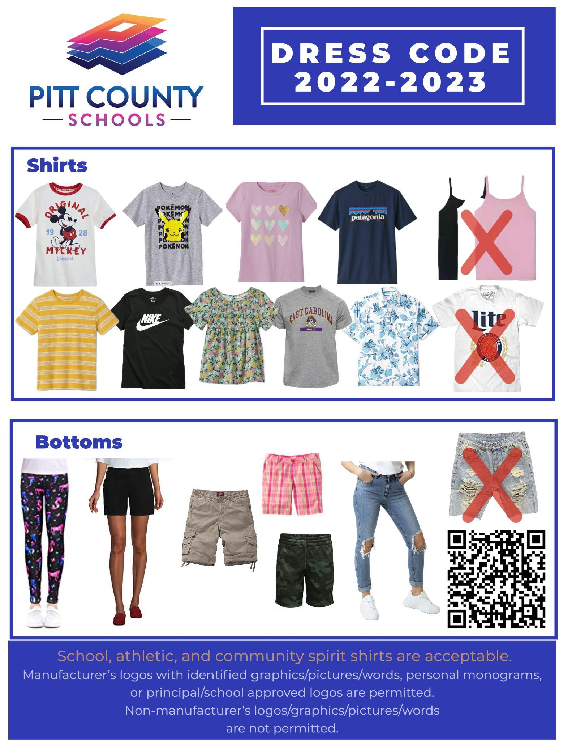

Refer to page 22 of the Pitt County Schools’ Parent/Student Handbook for additional School Uniform Requirements.

**EMERGENCY/SAFETY DRILLS**

***Severe Weather Plan***

All teachers will be notified of impending weather conditions and a plan will be reviewed. In the event of a tornado all blinds and drapes are lowered and students are relocated to areas offering the greatest tornado resistance.

***Tornado Drill***

* Tornado drills will take place periodically during the school year.
* THIS DRILL TAKES PRECEDENCE OVER EVERY OTHER SCHOOL ACTIVITY.
* The signal for the drill is a bell ringing for 5 sec, followed by silence for 2 seconds in a

repeating cycle.

Tornado Drill continued…

* It is essential that when the first signal is given, everyone obeys orders and promptly relocates to designated areas.
* Students will be seated on the floor with their backs to corridor walls or glass areas. Coats and jackets can be used to cover heads, arms and legs so as to reduce the number of injuries from flying glass and other debris.
* Students are expected to be quiet, alert, and attentive during the drill. The drill is a serious undertaking and inappropriate behavior will not be tolerated.

***Fire Drills***

* Fire drills at regular intervals are required by law and are important safety precautions.
* THIS DRILL TAKES PRECEDENCE OVER EVERY OTHER SCHOOL ACTIVITY.
* The signal for the drill is a long continuous bell or a fog horn.
* It is essential that when the first signal is given, everyone obeys orders and promptly clears the building by the prescribed routes.
* When the signal for the drill is given, students should stand and leave the room single file.
* Students are not to break the single file line and running is not permitted. The last person out should see that all windows and doors are closed.
* Everyone will remain in single file and a safe distance from the school until the signal is given that it is safe to return to the building.
* Students are expected to be quiet, alert, and attentive during the drill. The drill is a serious undertaking and inappropriate behavior will not be tolerated.

***Lock Down Drills—***Two lock down drills will be held this school year. The purpose of the practice drills is to prepare our learning community on how to respond during emergency situations. After each drill, families will receive an automated telephone message or a letter from school to confirm that a practice drill was held.

**USE OF MEDICATION**

It is the policy of Pitt County Schools that medication should not be administered to a student during school hours or by school personnel unless proper medical documentation is approved by the school nurse. Refer to page 8 of the Pitt County Schools’ Parent/Student Handbook.

**RIDING BICYCLES**Students may ride bicycles to school. They are to be parked upon arrival at school and are not to be used until the end of the school day. All bicycles should be secured with a lock. The school is not responsible for damage or theft of parts while bicycles are parked in the racks. The parking area is located on Blount Street side of campus.

**ATTENDING ASSEMBLIES**

Assemblies are a regularly scheduled part of the curriculum and as such, are designed to be educational as well as entertaining experiences. They provide one of the few opportunities in school to learn formal audience behavior. Regardless of the type of program, courtesy demands that the student body be respectful and appreciative. With live entertainment, unlike radio, television or movies, the performers are very conscious of their audience. Talking, whispering, whistling, stamping of feet, and booing are discourteous. Yelling is appropriate only at pep rallies.

**STUDENT AWARDS/RECOGNITION**

Throughout the year and at the end of the year are our awards assemblies. Students are recognized for outstanding academic, cultural, extra-curricular, and athletic achievements. The following represents a list of available student awards:

**Nine Week Recognition**

* Honor Roll/Principal’s List (Refer to page 10 of the PCS Parent/Student Handbook)
* Academic Achievement Celebrations-- Achievement parties are held three times a year to recognize and celebrate students’ academic success. All students who achieve all A's and/or B's on their report card are eligible to attend.
* Positive Behavior Intervention Support (PBIS) Celebrations—Celebrations are held three times a year to recognize and celebrate students’ positive behavior. All students who are not assigned to Choice, In-School Suspension, Project Equal, Out-of-School Suspension or Bus Suspension are eligible to attend.

**Annual Awards** (End of the Year)

**Grades 6-8**

* Academic Excellence Awards - to outstanding students in the areas of Communication Skills, Math, Science, & Social Studies
* Excellence in Cultural Arts - to outstanding students in the areas of Art, Band, Chorus, & Orchestra
* Awards of Participation - to outstanding students in the areas of Beta Club,

Math Team, Battle of the Books, and Peer Helpers

* AG Cox Game Changer Award

**Additional Awards Grades 7-8**

* Duke Talent Identification Program - 7th
* Best All Around( Boy & Girl) 8th
* Bonnie K. Langston Award - 8th
* DAR Good Citizenship Award - 8th
* Presidential Academic Excellence Awards - 8th
* Barbara Ayers-Best Social Studies Scholarship – 8th
* Phyllis Carraway Citizenship Award – 8th
* Tony Banks Memorial Award - 8th
* Barney Barker Band Award - 7th
* Bill Brookshire Award – 7th and 8th
* Lana Dunn Service Award – 8th
* Tracey Cole Leadership Award – 8th

**PARENT TEACHER ORGANIZATION**

The Parent Teacher Organization (PTO) is an organization that allows parents to work closely with teachers, staff, and other parents to organize and develop activities to motivate our students’ academic growth. PTO Membership is $5 for the year. If you are interested in being involved, you may join at Open House night and during other school events, or call our school at 756-3105 for more information.

**COUNSELING SERVICES**

A. G. Cox has two full time school counselors who will provide a variety of services to assist students, parents, and teachers. Our counseling program is designed to help students develop self-understanding and interpersonal skills. Students are encouraged to become familiar with and utilize the services of our counselors.

***Services include***

* New students
* Testing and test interpretation to assess academic progress
* School-Based Committee chairperson
* Works closely with the Teacher Assistance Team to address identified student needs
* Individual and group counseling to address special concerns or issues
* Provides students with educational, occupational, and pertinent personal information
* Coordinates health and referral services
* Coordinates parent-teacher conferences to assess academic performances or to address specific student needs

**PARENT-TEACHER CONFERENCES**

Communication between parents and teachers is essential. Feel free to contact your child’s teacher to schedule a conference. Teachers need time to properly prepare for all conferences. To schedule conferences, parents are requested to contact the counselors’ office. Parents may contact their child’s teacher directly by calling, e-mailing, or writing a note in their child’s agenda. Parents may also contact the counselor’s office.

# PARENT EXPECTATIONS, INVOLVEMENT, AND RESPONSIBILITIES

Parents are expected to be role models for students while on campus and at all school events. Parents must check in with the main office upon entering a building prior to visiting with a teacher or team.

Education works best when there is a strong partnership between home and school, a partnership that thrives on good communication. Become familiar with all your child’s school activities and with the academic programs our school has to offer. If you have questions about anything related to your child’s progress or opportunities, please speak with a teacher, counselor, or school administrator.

**SCHOOL-BASED COMMITTEE**

The school-based committee provides a team framework for evaluating data and recommending the most appropriate placement for children referred for special education services. It is responsible for receiving referrals, involving parents in the planning process, obtaining parental permission for assessment, initiating screening and evaluation procedures, evaluating information, seeing that an individualized education program for students identified with a disability, group education program for the academically gifted or written educational program for the pregnant is developed, and is reevaluated annually.

**MTSS (Multi-Tier System of Support) TEAM**

The MTSS Team helps regular education teachers with intervention strategies to meet the needs of all students. It is responsible for analyzing results of interventions and making appropriate recommendations.

**WITHDRAWAL PROCEDURES**All students withdrawing from A. G. Cox do so through the Data Manager’s office. Parents must notify the school by telephone or in person.

**STUDENT SERVICES**

***School Social Workers*** have multiple school assignments and work in K-12 schools on a weekly and as needed basis. Social workers serve as a liaison between home, school, and community, with a primary focus on encouraging parental input and involvement. Assistance is provided in identifying and addressing concerns through assessment of the influences in a student’s total environment that may impact the educational setting. Direct services are provided to students and families in the school and home that include individual, group, and family counseling, community resource information and referral, and advocacy. Consultation with staff, parents, and community is provided to address students’ needs, school board policy and procedures, and family and child welfare laws.

***School Health Specialists*** are being provided by Pitt County Memorial Hospital to serve the K-8 schools on a weekly basis. These professionals are Registered Nurses and have multiple school assignments. Coordination of health care services is provided to promote healthy lifestyles and behaviors, disease and injury prevention education, evaluation of specific medical concerns affecting student achievement, linking students to health care providers, medication management, and assisting with coordinating care of children with exceptional needs.

**HARASSMENT / BULLYING**

All students have the right to attend school and school-related activities without any discrimination on the basis of race, color, sex, religion, national origin, or disability. Students are expected to treat other students and school employees with courtesy and respect, to avoid any behaviors known to be offensive, and to stop these behaviors when asked or told to stop.

A student who believes her or she has been harassed, in any way, by another student or by a school employee is encouraged to report the incident to a teacher, counselor, or school administrator. The allegations will be investigated and addressed. A substantiated complaint against a student will result in disciplinary action, according to the nature of the offense and the Pitt County Schools Student Code of Conduct. The school resource officer will be involved in most cases, as is necessary.

Such action shall be responsible to EEOC (Equal Employment Opportunity Commission) definitions; Section 703 (a), Title VII provisions; standards resulting from relevant court actions dealing with the liability an employer incurs for sexual harassment acts of supervisory personnel; and Title IX of the 1972 federal Education Act.

**PEER MEDIATION**

Peer mediation is a program designed to help students resolve conflicts without resorting to violence. Students who have been trained in conflict resolution are available to help other students. Peer mediators work with a counselor to help mediated students arrive at a resolution agreeable to all parties.

**Student Code of Conduct**

All students will have access to The Code of Student Conduct, which explains rules and consequences utilized in Pitt County Schools. The Code of Student Conduct can be found in the Pitt County Schools’ Parent/Student Handbook starting on page 27. In addition, the following are our general school rules and consequences.

At A. G. Cox, we focus on the teaching and learning environment that is conducive to quality instruction. We encourage our faculty and staff members to serve as role models and mentors for all students. We hold high expectations for our students in creating a safe environment where respect for others reigns as the guiding force in all decisions. To ensure that we maintain the safest environment and preserve quality instructional time, we have established rules and procedures that we will practice at our school. Those student behaviors that interfere with teaching and learning will not be tolerated on this campus. Teachers are held responsible for teaching the accepted behaviors that we expect from students. Therefore, we hold students accountable for their behavior, and certain behaviors carry negative consequences. The best discipline is self-discipline and each student is in charge of his/her attitude.

**EXPECTATIONS AND CONSEQUENCES**

**Everyone should show respect for all people, personal property, and school property**. Fighting and/or aggressive behavior will not be tolerated. Students who choose to fight could face up to ten-day suspension from school. Some examples of inappropriate behavior include (but are not limited to): horseplay, play fighting, and verbal altercations, profanity directed towards a faculty member, staff member, student, or anyone on this campus; failure to identify one’s self when directed to do so; outright defiance in response to a reasonable request by a faculty or staff member; failure to report to the office when directed to do so; repeated failure to follow instructions; interference with teaching and learning by constant disruption. When a teacher refers a student to an administrator for disrespectful behavior, the offenses will be dealt with according to PCS’s

[Code of Student Conduct](https://www.pitt.k12.nc.us/Page/7194) Parent/Student Handbook.

**All students should help create and maintain a positive and safe learning environment**. Bus conduct, hall conduct, cafeteria conduct, media center conduct, gym conduct and classroom conduct should be appropriate for a school setting. There are some items that should never be in a student’s possession whether on the bus or on school property. These items include (but are not limited to): weapons or any items that may be used as a weapon, drugs, alcoholic beverages, tobacco products, or any item that appears to be unlawful. Illegal activity of any kind will not be tolerated and the consequences for possession or use of any aforementioned item will result in suspension.

**All students should be prepared to actively engage in classroom activities**. In order for students to learn, there are certain items that are deemed unacceptable on our campus. Inappropriate use of items such as: cell phones, I-pods, beepers, MP3 Players, cameras, DVD players, games (electronic or otherwise), playing cards, items for sale, will not be allowed and will be confiscated and returned at the discretion of the principal. **Recording inappropriate student conduct is against school policy and will result in school consequences.**

**Gang behavior and gang related activities will not be tolerated**. A gang is any ongoing organization, association, or group of three or more persons, whether formal or informal, having as one of its primary activities the commission of criminal acts, or the purposeful violation of any PCS policy, and having a common name or common identifying signs, colors or symbols. Conduct prohibited includes:

* Wearing, possessing, using, distributing, displaying, or selling any clothing, jewelry, emblems, badges, symbols, signs, visible tattoos and/or body markings, or other items, or being in possession of literature that shows affiliation with a gang, or is evidence of membership or affiliation in any gang or that promotes gang affiliation;
* Communicating either verbally or non-verbally (gestures, handshakes, slogans, gang signing, drawings) that convey membership affiliation in any gang or that promotes gang affiliation;
* Tagging, or otherwise defacing school or personal property with gang or gang-related symbols or slogans;
* Inciting other students to intimidate or to act with physical violence upon any other person related to gang activity;
* Soliciting others for gang membership;
* Requiring payment of protection, money or insurance, or otherwise intimidating or threatening any person related to gang activity.

In addition to the system and school-wide policies above, each team and encore teacher will have individual classroom rules that outline their expectations so they can maintain a high teaching-learning atmosphere. Teams and grade levels may use the all or parts of the PBIS Criteria outlined on page 30 for grade level or special events. Teams or grade levels will communicate these expectations to parents and students.

**SCHOOL BUS DISCIPLINE POLICY**

***Riding the bus is a privilege given by the state of North Caroline, which may be withdrawn for misbehavior or for any reason deemed necessary to ensure student safety.***

Any and all discipline problems that occur on the school bus will be dealt with according to the Pitt County School’s Parent/Student Handbook. Please refer to page 24. All school rules are in effect on any bus. Failure to adhere to those rules will result in suspension from riding the bus or suspension from school. A bus suspension is not considered a school suspension.

**Classroom Removal**

Students who disrupt class will be sent to the front office. Repeated class disruptions or office referrals will result in remote learning. Parents will be notified of all suspensions.

**OUT OF SCHOOL SUSPENSION**

Students and parents should familiarize themselves with the Pitt County Schools’ Parent/Student Handbook. Policies associated with the Parent/Student Handbook will be strictly adhered to, and all violators will be dealt with in a fair, equitable, and consistent manner. Parents will be notified any time students are suspended from school. Online learning will be available for all students when he/she is not in school

**AG Cox Classroom Discipline Continuum**

**For “Minor” Infractions**

1. Warning – Daily
   1. “Bounce” to another classroom
   2. Telephone call to parent
   3. “Choice” Time-Out
2. Front Office & Telephone call to parents

**Notes:**

Faculty and staff members will call parents as soon as possible after an incident occurs. If the faculty and staff are not able to reach a parent/guardian, they will make every effort to leave a voice message regarding the incident.

Faculty and staff members have the right to by-pass giving a warning or bouncing a student if the student’s behavior is severe. In these cases, the students may be sent directly to CHOICE or a teacher may complete an office referral to help correct the inappropriate behaviors.

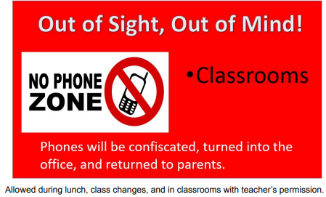

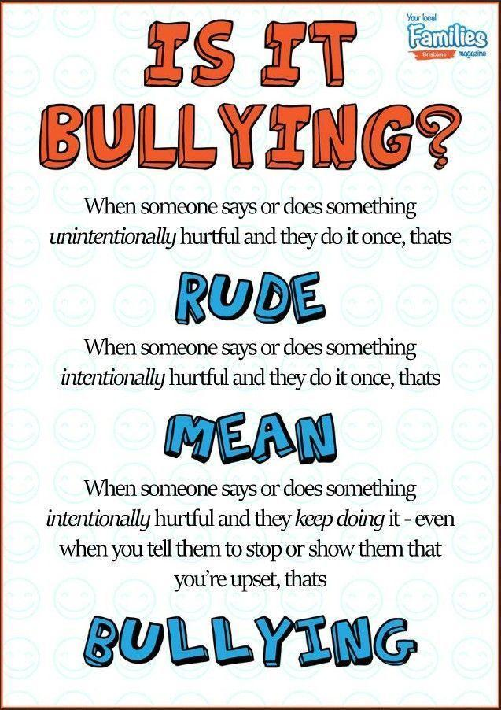

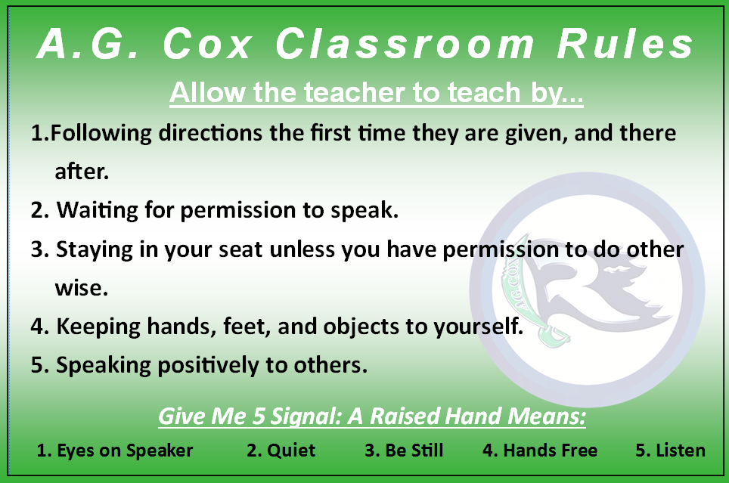

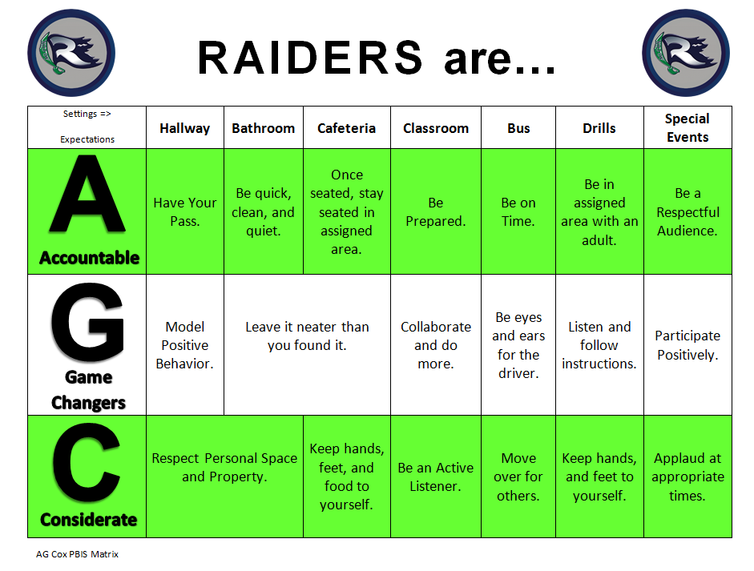

**AGC Bell Schedule**

| **6th** | **7th** | **8th** | **8th**  **4th person team** | **Elective** |
| --- | --- | --- | --- | --- |
| Homeroom  8:15 - 8:30 | Homeroom  8:15 - 8:30 | Homeroom  8:15 - 8:30 | Homeroom  8:15 - 8:30 |  |
| CORE 1  8:30-10:00 | CORE 1  8:30-10:00 | CORE 1  8:30-10:00 | CORE 1  8:30-9:37 | Planning |
| Elective  10:04-10:51 | CORE 2 / Lunch  10:03-12:00 | CORE 2 / Lunch  10:03-12:12 | CORE 2  9:40-10:47 | 6th Elective  10:04-10:51 |
| Elective  10:55-11:42 | Elective  12:04-12:51 | CORE 3 / Lunch  10:50-12:35 | 6th Elective  10:55-11:42 |
| Lunch  11:42-12:00 |
| CORE 2 / Lunch  11:46 – 1:57 | Elective  12:55-1:42 | CORE 3  12:15-1:46 | CORE 4  12:39 – 1:46 | 7th Elective  12:04 -12:51 |
| CORE 3  1:46 – 3:30 | Elective  1:50-2:37 | Elective  1:50-2:37 | 7th Elective  12:55-1:42 |
| CORE 3  2:00 – 3:30 | Transition  1:42-1:46 |
| Elective  2:41-3:30 | Elective  2:41-3:30 | 8th Elective  1:50-2:37 |
| 8th Elective  2:41 – 3:30 |

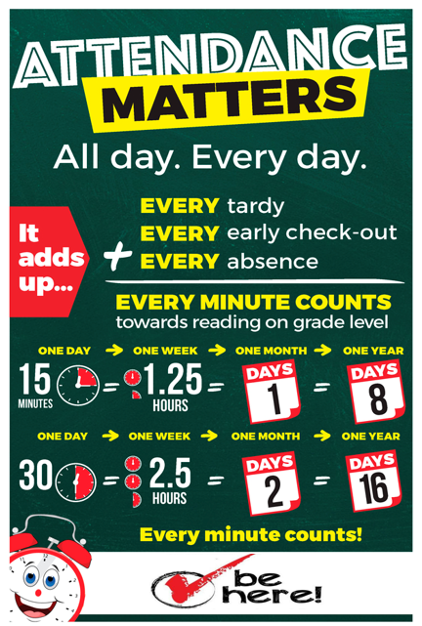

School of Engagement

Attendance - Attachment - Achievement

